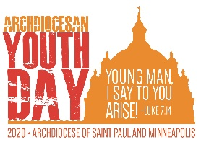
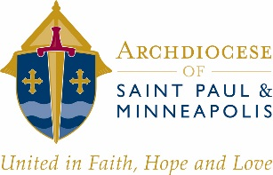
Archdiocesan Youth Day 2020
Group Leader Agreement

Parish: City:
Group Leader: Cell Phone:

In preparation for Archdiocesan Youth Day 2020, and to outline your responsibilities regarding registration, liability forms and Office of Protection of Children and Youth (OPCY) requirements to conform to the Charter for the Protection of Children and Young People, please review these requirements, sign below and return. You, your safe environment coordinator, and your pastor will be required to provide a signed E3 chaperone roster stating that these requirements have been met. These requirements are to ensure the safety of all those attending AYD20 and our ability to respond appropriately to unforeseen events. In addition, they will be required to ensure that the necessary insurance coverage exists for your parish, its chaperones and your participants.

By signing below you agree that:

- All chaperones will be OPCY Essential 3 qualified (records to remain at the parish).
  - Signed Code of Conduct
  - Completed and clear Background Check
  - Attended a VIRTUS: Protecting God’s Children awareness session
- All participants will:
  - Have an approved release of liability form signed and on file at the parish.
    - This form must include a use of image waiver
  - Review and agree to observe the general event behavior guidelines (sample attached).
- You will have on hand at the event emergency contact information for each participant in your group.
- You will provide, at the time of entry into the event, the completed AYD Group Roster Form.

Signature:

Date:

