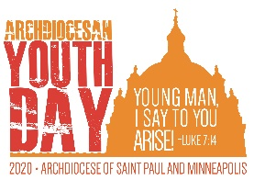
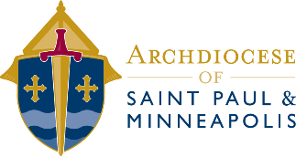
Archdiocesan Youth Day 2020
Group Leader Information

Registration (Deadline October 1)
Your group registration is not complete until the following items are received:
- Group Registration Form (Excel)
- Group Leader Agreement
- E3 Chaperone Roster
- Payment ($25/person)
All registration materials can be found on the Archdiocese of St. Paul & Minneapolis website. Email completed registration forms to aydregistration@archspm.org or mail them to:
Archdiocese of Saint Paul & Minneapolis
ATTN: Archdiocesan Youth Day
777 Forest St.
St. Paul, MN 55106

Payment can be made via credit card or check. Please contact Sonya Flomo at (651) 291-4515 or flomos@archspm.org to pay by credit card or make one check payable to the Archdiocese of St. Paul & Minneapolis from your parish.
In addition to registration, please note the following:
- Keep a copy of every form you send in and bring it with you to AYD20 in case of emergency.
- Refunds can only be granted up to October 1.
- Additional registrations may be added up to November 1 by mailing in a check, or paying via credit card.

Check In
- All participants should be dropped off at the doors to Saint Thomas Academy.
- There will be a staging area for the youth and chaperones to wait as the group leader checks in.
- Only the group leader should check in. If you have a large group, one additional chaperone may go with the group leader to check in.
- Bring your completed group roster to check-in with the names of only those who are present at AYD20, not everyone who is registered.

AYD20 T-Shirts
- AYD20 t-shirts will be available.

Service Project
- With the help of people from our Archdiocese, the Archdiocesan Council of Catholic Women has held a Christmas Mission Project for over 30 years. This year, we are once again asking you to participate by bringing shoeboxes and other items to AYD to send to the young people of Appalachia.

Volunteers
- An event like this takes many hands to pull off smoothly, please consider asking an adult or two from your parish to volunteer for the day.
- Every volunteer must be up to date with the Enhanced Essential 3 requirements (Background Check, VIRTUS training, and Code of Conduct).
- A roster for volunteer participants can be found with the registration documents.

Other Notes
- Archbishop Hebda encourages pastors to attend the Liturgy, if possible.
- Youth will need to arrive with their group to be admitted. Late arrivals and re-entries are not permitted for this event.
- Doors open at 12:30 p.m. SONAR will begin at 1:30 p.m. with music.

Prayer
- This day promises to be a life-changing moment for many youth in our Archdiocese. Please keep the event and the hundreds of attendees in your prayers.
Resources
- Registration Documents
- Promotional Materials
- General Schedule
- General Behavior Guidelines
- Service Project Information
- …and more.

